OPERATING SYSTEMS PROJECT 1 REPORT
(Fatmanur ÖZDEMİR – 150116046 Kevser İLDEŞ - 150116048)

1) First script of a project is to find palindrome string with the given argument.

For this purpose, firstly required controls are made such as no argument, not a string, all alphabet, special characters etc. Then given string is turned all lowercase.
After that, string given is reversed char by char using for loop and next, with another for loop two strings are compared. If no mismatch occurs then script outputs palindrome.

Here is screenshot of outputs for some different input cases:

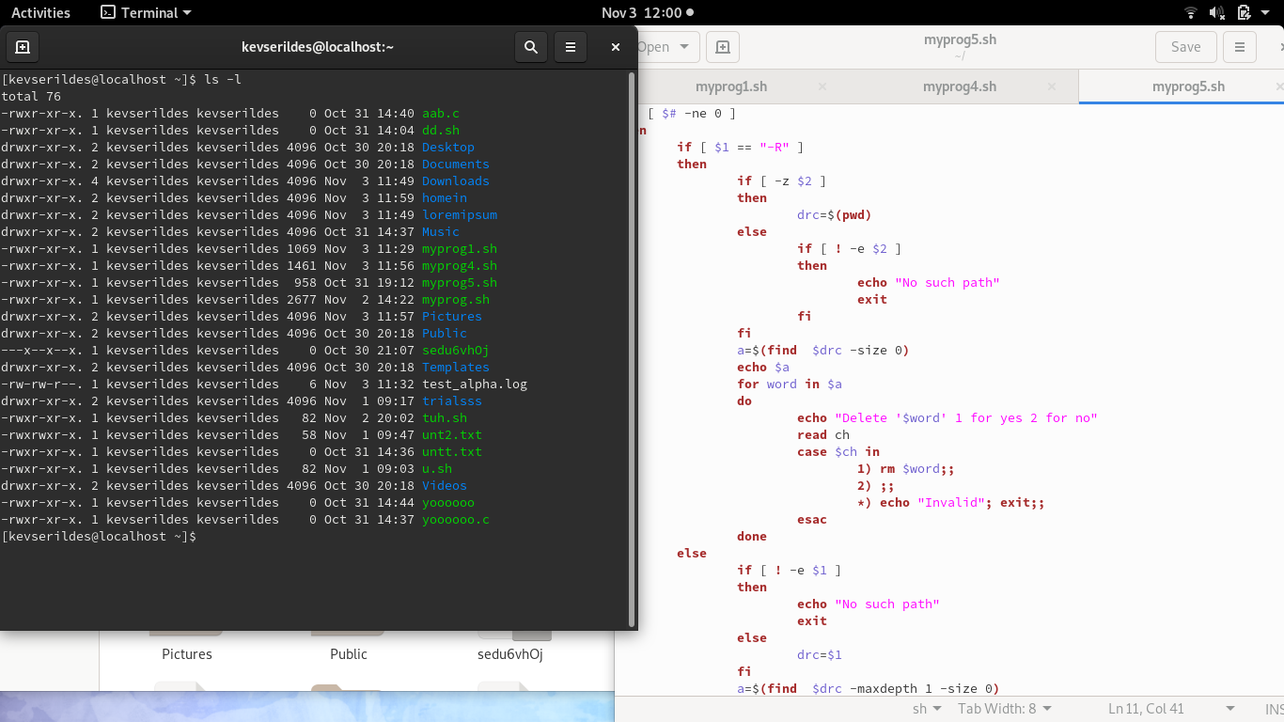
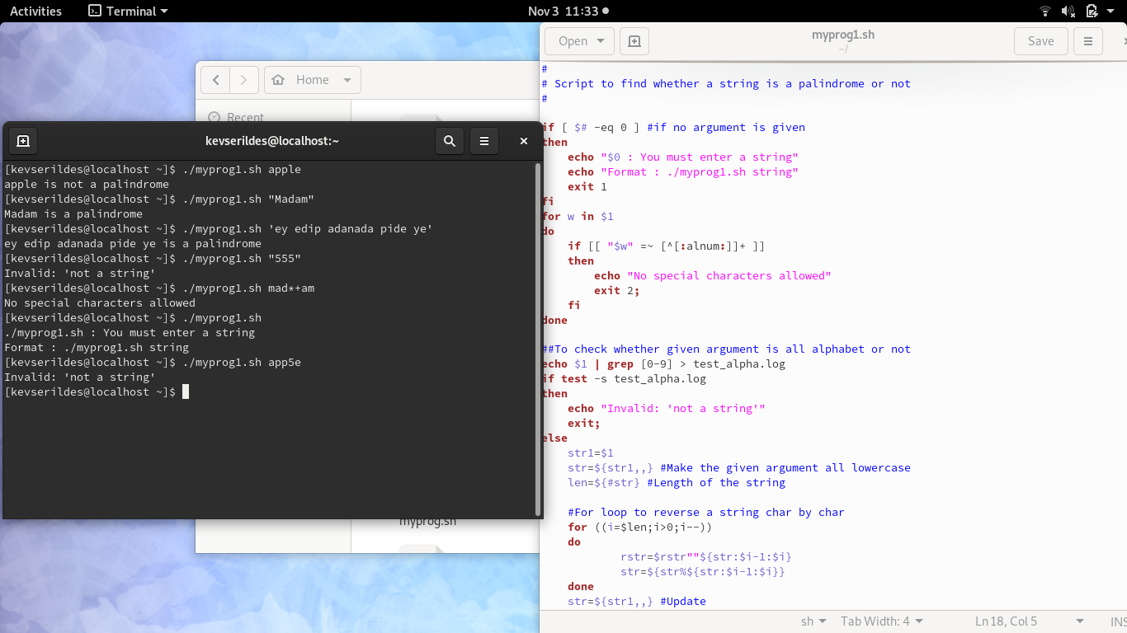
2) In the second part, user enters pathname as optional parameter. If user enters path name, the program will create a ‘cprogs’ directory under pathname given by user and move all the files whose ends with .c to this directory. If user does not enter any parameter, the program will do the same process under current directory.

At first, the program checks whether user entered an input as parameter or not. If he did not, program searches all files which ends with .c by ‘find’ command and passes them to the variable named as ‘res’. Then ‘cprogs’ directory is created with ‘mkdir’ command and all the .c files are moved into this directory with ‘mv’ command.

If user enters a pathname, the program checks if there is a directory as given parameter. If there is not a path as given parameter, the program gives an error. Otherwise program does the same process when user did not give a pathname.

Here is screenshot of sample execution:
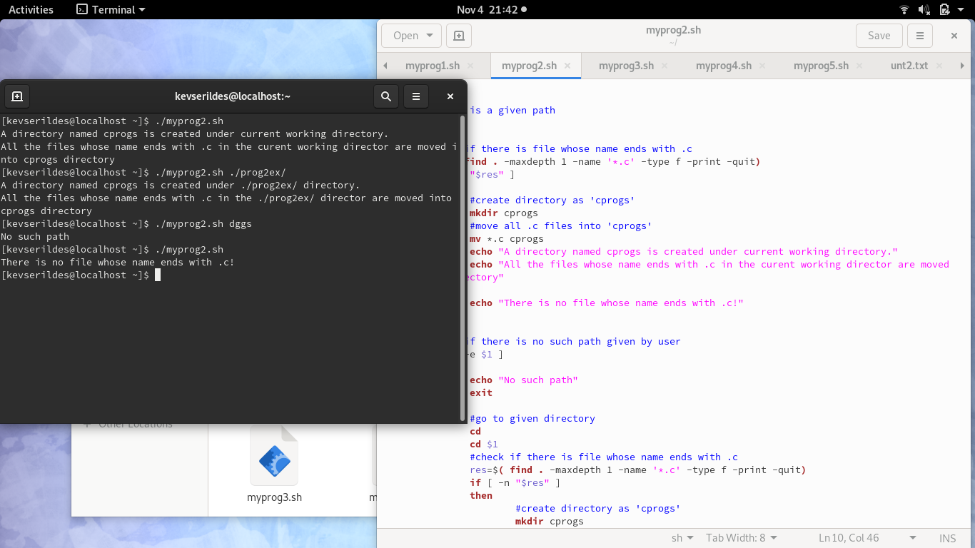
3)In the third part, program gets two integers. First of the integer must be bigger than the second one and the difference must be even. The program makes two hollowed squares. The first integer indicates the number of stars on one side of the outer square. The second integer indicates the number of stars on one side of the inner square. The outer square is made with ‘*’ sign. The inner square is made with ‘blank’ sign.

Firstly, the program checks whether user entered invalid input or not. If he enters invalid input, program gives an error. If he did not, it draws the hollowed square.

There are 3 for loops in the shell code. The first one constitutes the rows of the shape. In the second for loop, the ‘*’ or blank sign is printed on the screen. Since the number of stars on top and bottom will be equal, the program divides difference in half. It starts to print ‘*’ sign, until half difference. When it comes to half, it prints blank sign in the third loop. The bottom limit is calculated in reverse. The half of the difference is subtracted from first integer. When the current row number becomes equal to that calculated number, inner square is completed. The ‘*’ sign continues to be printed and the outer square is completed as well.

Here is screenshot of outputs for some different input cases:

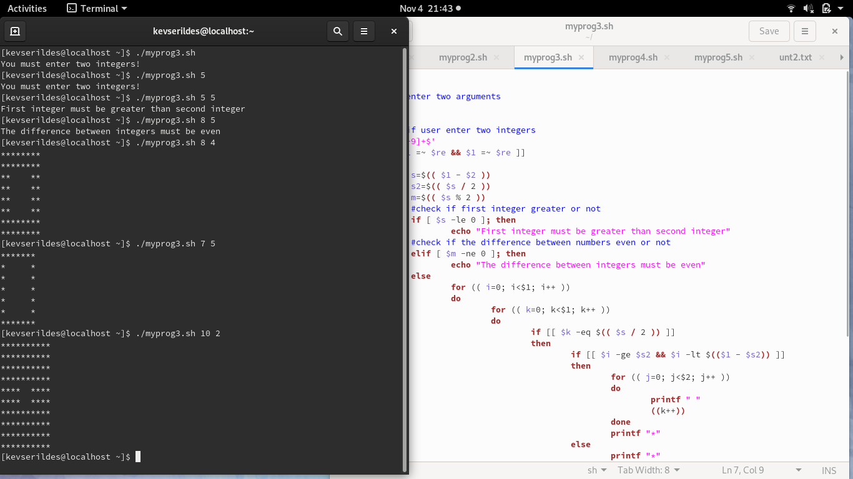
4) In fourth part, a wild card string is taken, searched in all text files and whenever a match occurs it is turned to all uppercase and prints information to user.

At the beginning of script, again necessary checks are made and proceed according to whether a specific directory is given or not.
Then if there is at least one text file exists in directory, it keeps all text files’ names in a variable by using ls. Next, it takes the content of each file one by one with the help of cat command and loop through text. Whenever a match occurs the word in file is changed to all uppercase by sed command and user is informed about that change.
After all text files are checked, program ends.

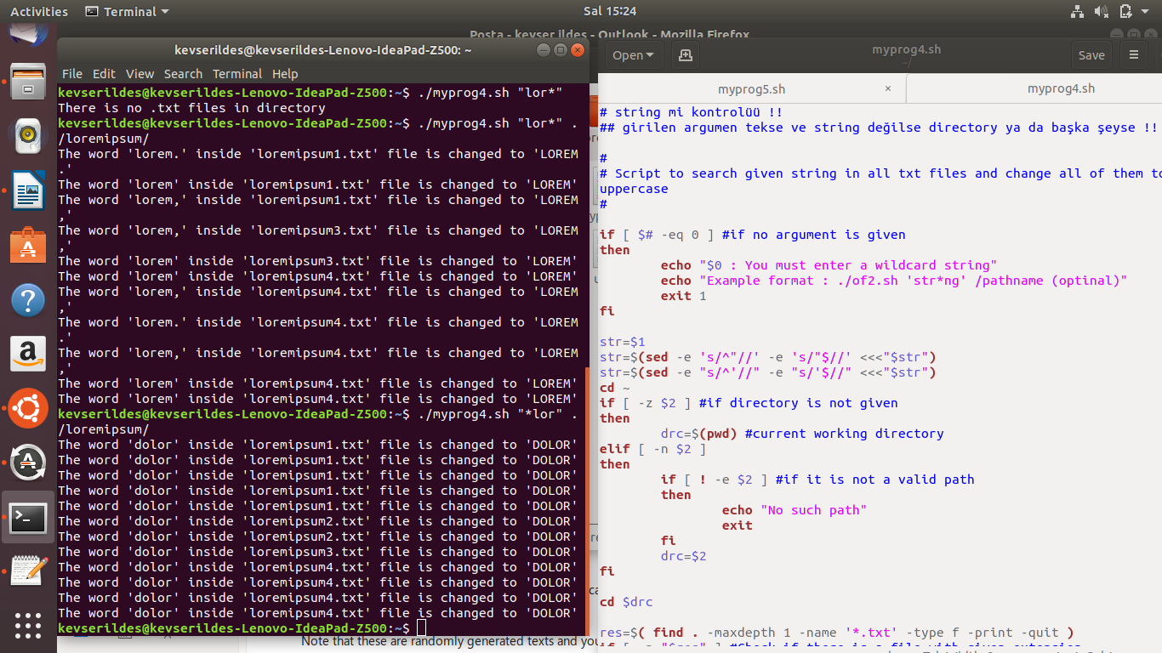
Here are screenshots of execution:

5) In fifth part of the project, it looks for all files whose size is zero and then asks the user to delete it or not.

Firstly, after necessary checking, according to users’ inputs (just -r, just directory or both) it finds files with zero size with find command.
After that, it asks the user whether to delete them or not one by one and if the choice is ‘yes’, then script deletes that file by rm command and informs user.

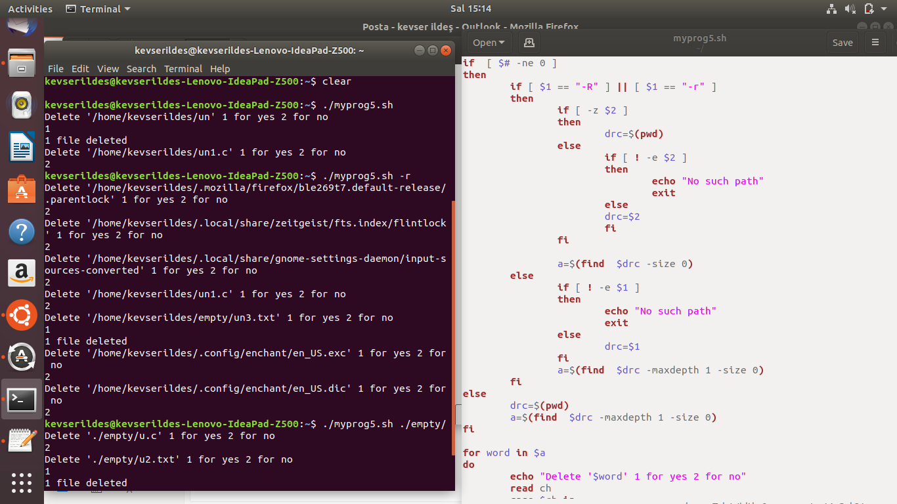

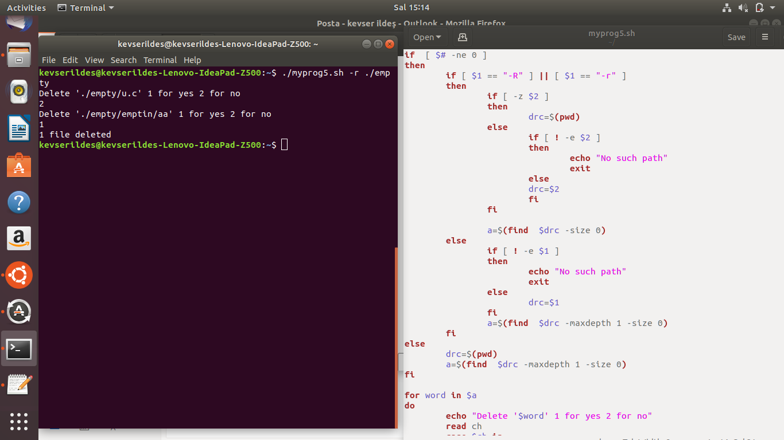

6) The bonus part is the menu that consist of all 5 scripts.

It just takes the choice and asks whether parameters will be given or not and then executes related script with given parameters.

Here is sample execution:

